A.I Lab Manual By Saqib Hussain

Roll No: BIT-23F-014

Python Programming Tasks (python looping tasks)

1. Print numbers from 1 to 10 using a for loop.

for i in range(1, 11):

print(i)

**Output**

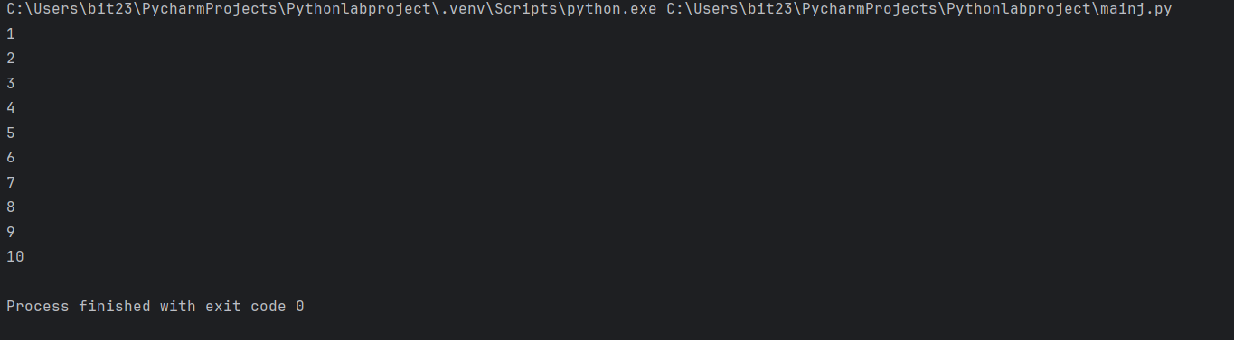

**2. Print all even numbers between 1 and 20 using a while loop**

i = 2

while i <= 20:

print(i)

i += 2

**OUTPUT**

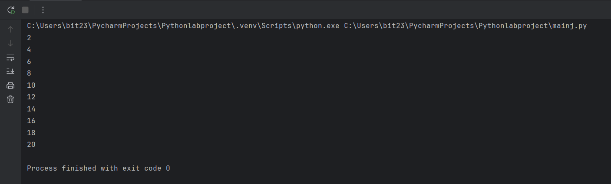

**3. Calculate the sum of numbers from 1 to 100 using a loop**

total = 0

for i in range(1, 101):

total += i

print("Sum from 1 to 100 is:", total)

**OUTPUT**

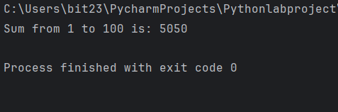

**4. Print the multiplication table of 5 using a loop**

for i in range(1, 11):

print(f"5 x {i} = {5 * i}")

**OUTPUT**

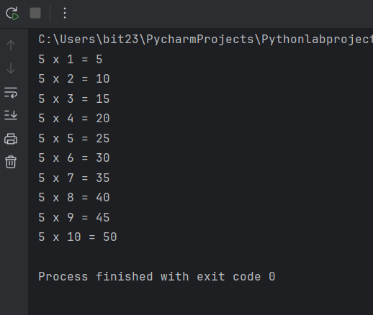

**5. Find the factorial of a given number using a for loop**

number = 5 # You can change this number

factorial = 1

for i in range(1, number + 1):

factorial *= i

print(f"Factorial of {number} is: {factorial}")

**OUTPUT**

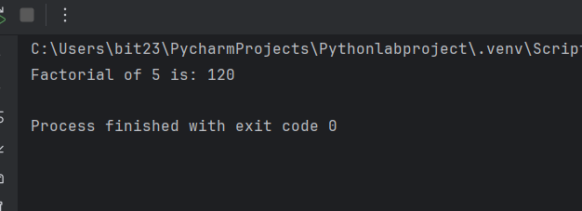

**6. Iterate over a list of fruits and print each item**

fruits = ["apple", "banana", "cherry", "orange"]

for fruit in fruits:

print(fruit)

**OUTPUT**

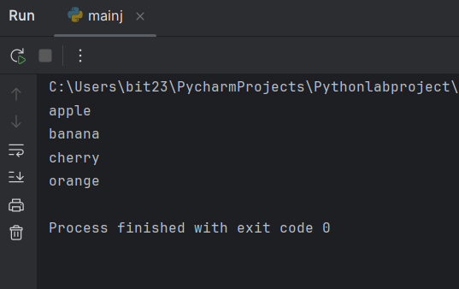

**7. Create a list of numbers and print only the odd numbers using a loop**

numbers = list(range(1, 21))

for num in numbers:

if num % 2 != 0:

print(num)

**OUTPUT**

